# Assignment 1 Install Python IDE

1)Download the Anaconda from the website  <https://www.anaconda.com/download/>

2)The version that I have downloaded was Anaconda3-2021.05-Windows-x86_64

3)Install the downloaded execution file.

4)Launch the Anaconda from the start menu.

5)It would open the Anaconda Navigator as shown below.

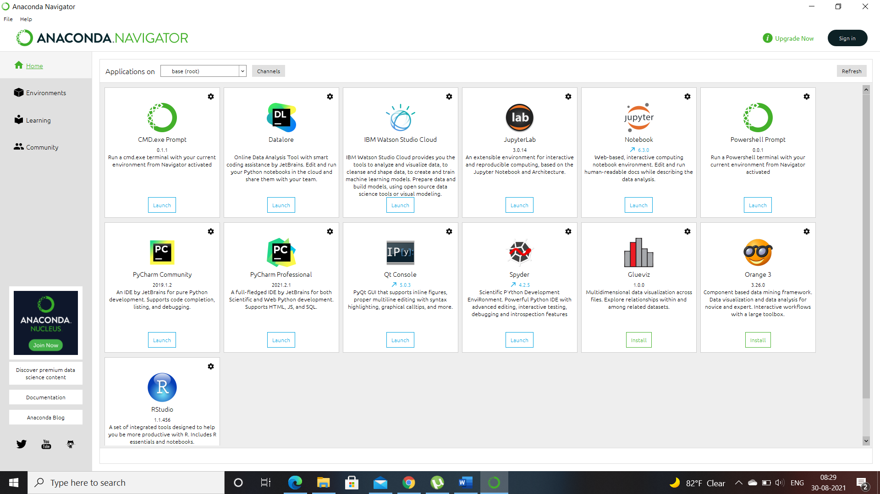

6)In the navigator click on the Launch button, that is placed below Jupyter Notebook, which would launch the jupyter notebook in the browser with the following url :- <http://localhost:8888/tree>

7)Below is the screenshot of the jupyter notebook which was launched using Anaconda.

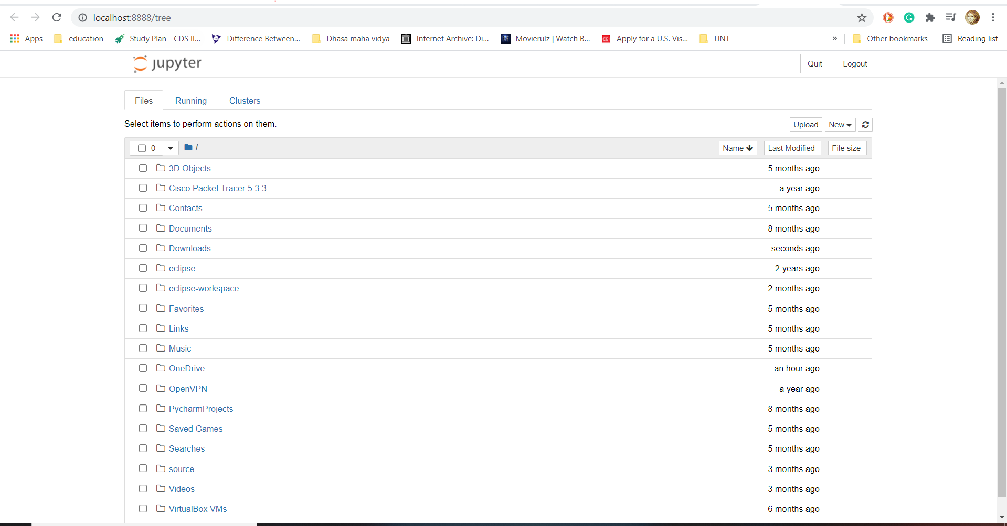s